**Weekly Assignment 6**

*Xiang Li (4013115)*

**1. Introduction**

The aim of this research is to identify factor structure from original 20 items in Toronto Alexithymia Scale (TAS-20).

**2. Method**

A total of 122 psychology students are in samples, and we collect the data of original 20 items in TAS, basic demographic information and total CES-D score on each of them. There is no missing data. In the data set, Sex is the only one binary variable and the other 22 variables including Age and CESD are all continuous variables. To figure out factor structure, we apply principal component analysis (PCA) on TAS-20 by R programming. Prior to implementing PCA, we center and scale each variable to have mean 0 and standard deviation 1. When deciding the number of keeping components, we attempt Kaiser’s rule, scree plot and Horn’s parallel analysis and take a comprehensive conclusion. For the sake of interpretation, the selected components need to be rotated.

**3. Result**

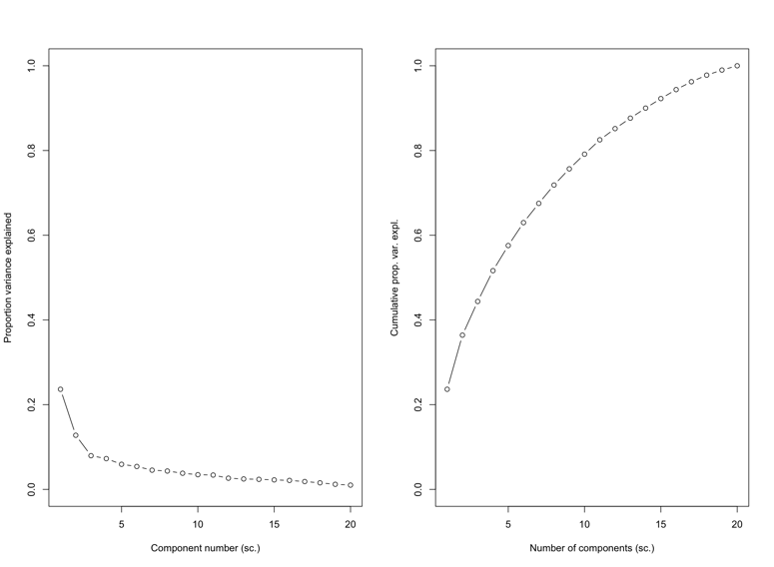

This figure shows the proportion of variance explained and cumulative proportion of variance explained in PCA results.

The number of selected components for each method is as follow.

|  |  |  |
| --- | --- | --- |
| Kaiser’s rule | scree plot | Horn’s parallel analysis |
| 6 | 2 | 4 |

We select the first 6 components. And the variance explained by first 6 components is 62.97%. After rotation, the variance explained by first 6 components is 30%.

**4. Conclusion**

PCA can identify factor structure from TAS-20 and PCA with rotation is more applicable.